Profile
Name: Fukuma Natsumi
family name given name
Nationality: Japan
Birth date: 05/07/2002 (day/month/year)
Age: 14 Sex: female
School (year): 8th grade in Ouchi Junior High School
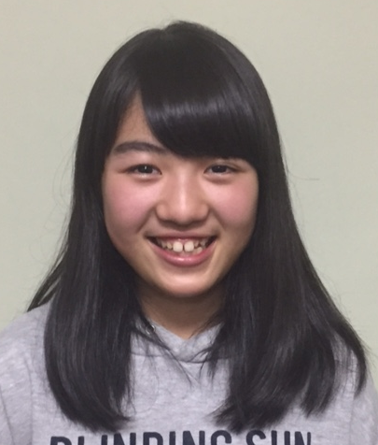
Family (name, age and occupation)
Father: Naoki, 49. office worker
Mother: Yukie, 46, nurse
Siblings: Shoichi, 18, 3rd year in high school

Allergy: None Religion: Buddhist

Message
Dear Family,
Thank you very much for becoming my host family. My name is Natsumi Fukuma. My family and friends call me Natchan. So please call me Natchan. I’m a member of the badminton club in my school. I like to make and eat sweets, and I like to listen to music, too.
I am very excited to go to the United States this spring. I want to see many things there. I want to make sweets with you, if possible. I can’t wait for visiting California. I’m looking forward to seeing you.

Sincerely,
福間 なつみ

